Norse Mythology Creatures
Mythological Creatures of the Norse, Viking or Scandinavian Mythology.
Dwarf  -small magical creatures with a mystic talent in metallurgy. | 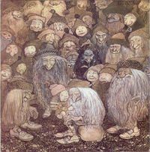
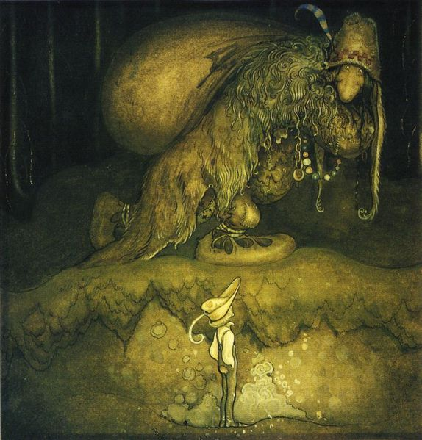 | Troll  -terrifying mythical creatures in Norse Mythology.  Often described with oversized nose and ears.  Norse folklore's own version of giants.
Sea Serpents  -sea monsters with serpentine appearance.  Numerous sightings have been reported but still no physical evidence. | 